HDMI on ZC706.

This project demonstrates how we can send video pattern from the Development board ZC706 via HDMI interface to the monitor. As a reference I used materials from Xilinx Video Series. The difference is that they used ZC702 board, which differs from ZC706 in several ways. Both boards have HDMI transmitter ADV7511, but the interface between Zynq and ADV7511 is not the same. Check Figure 1-15 in UG850 and Figure 1-21 in UG954. 16 data bits connected in ZC702 vs 24 bits connected in ZC706. This leads to different BDs in Vivado, different constraints, different IP settings and different application settings, I’ll tell in detail later.

The source of the video is Xilinx Video Test Generator core, VTPG (instantiated in BD in Vivado). In it configured and controlled from the application in SDK. Another two important IPs are Video Timing Controller (VTC) and AXI4-Stream to Video Out. VTC generates required timing signals for video (hsync, vsync, active video out for the selected video format. AXI4-Stream to Video Out converts AXI stream video into video stream.

Useful links:

Xilinx Video Series 19-21:

<https://support.xilinx.com/s/article/914989?language=en_US>

<https://support.xilinx.com/s/article/917308?language=en_US>

<https://support.xilinx.com/s/article/922324?language=en_US>

ZC702 and ZC706 datasheets:

<https://www.xilinx.com/support/documents/boards_and_kits/zc702_zvik/ug850-zc702-eval-bd.pdf>

<https://twiki.cern.ch/twiki/pub/Main/MpiMuonTrigger/UG954_BoardUserGuide.pdf>

ADV7511 user guide:

<https://www.analog.com/media/en/technical-documentation/user-guides/ADV7511_Hardware_Users_Guide.pdf>

Here are **steps to send simple video pattern from the board ZC706 to the monitor**:

1. Create Vivado project, launch runs, export to SDK:

* Open Vivado 2018.3
* In Tcl Console cd to the folder zc706_hdmi
* Run create_vivado_proj_zc706.tcl:

source create_vivado_proj_zc706.tcl

1. Create SDK project:

* Start the Xilinx Software Command Line Terminal (XSCT) 2018.3 from Xilinx Design Tools
* cd to the path of the zc706_hdmi
* Run create_SW_proj.tcl:

source create_SW_proj.tcl

1. Open SDK, connect board with the monitor, turn on the board, program FPGA, run application:

* Open SDK 2018.3 and select zc706_hdmi/sdk_workspace
* Connect board with the monitor using HDMI cable, turn on power on the board
* Program FPGA using Xilinx > Program FPGA
* Run the application (Right click on the Application > Run As > Launch on Hardware (System Debugger))

**Instructions on how to make a BOOT.bin and boot from SD card** (mostly taken from <https://www.css-techhelp.com/post/create-a-boot-bin-and-program-an-sd-card-with-a-on-windows>)

1. We need to create the first stage boot loader (FSBL) that will load the bitstream and the video application:

File->New->Application Project->”Project Name” = fsbl->Next->Zynq FSBL->Finish

1. Create BOOT.bin:
   * In the Project Explorer select fsbl;
   * Xilinx->Create Boot Image->Add->Browse to **tpg_hdmi_zc706_app.elf** in sdk_workspace\tpg_hdmi_zc706_app\Debug->Open->Ok->Create Image

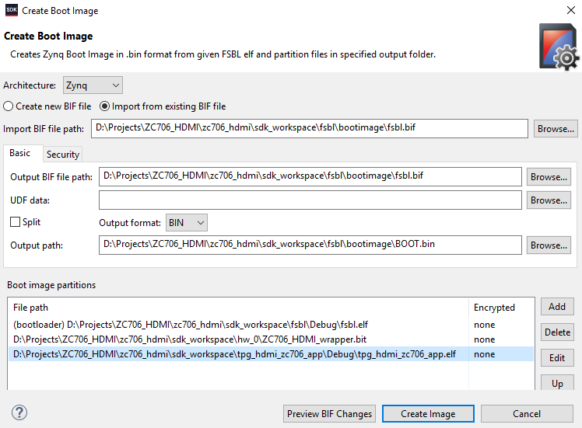

* + You should see Build Finished (took ...ms) ...and Bootgen command execution is done.

1. Format SD card to FAT32, copy BOOT.bin to SD card
2. Prepare the board and start it
   * Make sure the ZC706 is off and plug the SD card into the ZC706
   * Set the board to SD boot mode:

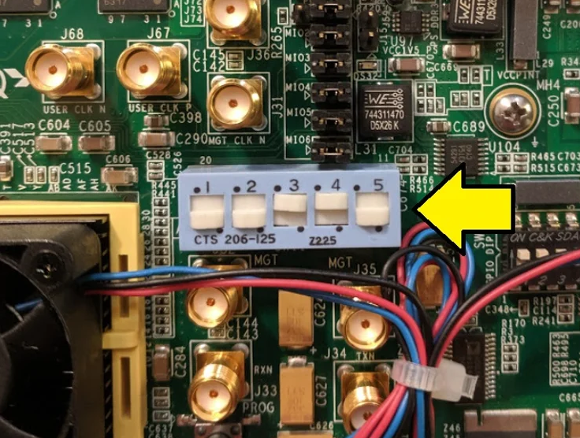

* + Power on the ZC706.
  + Moving green box should appear after a few seconds on monitor